FOR IMMEDIATE RELEASE
December 17, 2009

Media Contacts:
Copenhagen: Jamie Henn, jamie@350.org +45 52 68 47 65

The Real Climategate:
Civil Society Reacts Furiously to Leaked UN Document

COPENHAGEN -- Earlier this afternoon, leaked documents from the Secretariat emerged that demonstrate conclusively what we’ve been saying for months: the proposals now on the board would increase the planet’s temperature more than three degrees, and drive the concentration of co2 in the atmosphere above 550 ppm.

Download the document:

http://www.350.org/sites/all/files/leaked-UN-Climate-Doc.pdf

The leaked documents—which have the name of 350.org founder Bill McKibben scrawled across the top, for reasons we don’t know—make it clear that any claim that negotiators are aiming to hold temperature increases to 1.5 or 2 degrees are sham.

“In one sense this is no secret—we’ve been saying it for months. But it is powerful to have the UN confirming its own insincerity,” said McKibben.

The actual numbers for the current proposals are almost certainly even higher than the leaked document concludes. Climate Interactive, using an MIT software model, currently estimates we’ll see temperature increases of 3.9 degrees and a co2 concentration of 770 ppm by the year 2100.

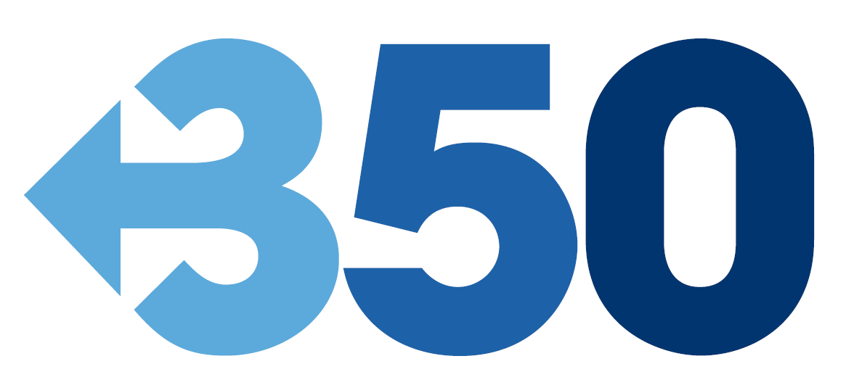
As word of the bombshell leaked Secretariat document has spread around civil society groups now barred from the negotiating hall, reaction has been fierce:
“This is the real Climate-gate—the UN has known all along that they were perpetrating a charade,” said Bill McKibben, at 350.org, whose name was scrawled across the top of the document. “It’s the smoking gun, and the smoke is coming from a scorched planet.”
“Twelve million people have called for a real deal that holds temperature increases to two degrees,” said Ben Margolis, director of the TckTckTck campaign. “Three degrees temperature rise would result in truly dire impacts.”
“The stark message for world leaders at Copenhagen is that the proposals on the table - especially from industrialised countries - fall far short of what the world needs," said Keith Allott, head of climate change at WWF-UK.

For a secret bonus chuckle, check out the very end of the document, which says that the estimated temperature rise of 3 degrees “will reduce significantly the probability to stay within a temperature increase of 2 degrees Celsius.” You think?

###

350.org is an international climate campaign working for a real deal that meets the latest science.

